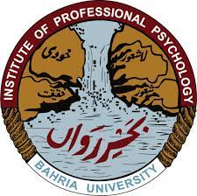
INSTITUTE OF PROFESSIONAL PSYCHOLOGY
BAHRIA UNIVERSITY KARACHI CAMPUS
ADMISSIONS SPRING 2022 SEMESTER
AFFIDAVIT

I S/ D / O Application No. Resident of do solemnly affirm declare as under:-
- That I am the deponent of this undertaking and hence fully conversant with the contents of this undertaking.

- That I appeared in HSSC-II / BACHELOR / MASTER Examinations Session_____________from/Board/University_____________________vide Roll Number .

- I declare that I will be able to obtain % marks as per eligibility criteria of the University.
- That the administration of Bahria University Karachi Campus has right to cancel my admission if I secure less than required percentage or fail to submit the result & IBCC Certificate in admission office till ____________

- That I will submit my documents attested by HEC and Equivalence Certificate from IBCC (whatever applicable). If I fail to submit these documents, Bahria University Karachi Campus has right to cancel my admission.

- That the contents of this affidavit are correct to the best, of my knowledge & belief and nothing has been concealed in this regards:

Student Name: Student Signature: ____________________
Father’s Name: __________________ Father’s Signature: ___________________
Date: Mobile No:

