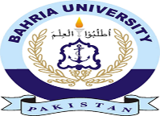
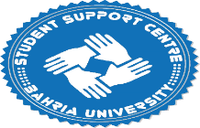

Alumni Activity - 30-Dec 2022 to 31-Jan, 2023

Mock Interview session for corporate skills course, BBA Semester 8th Section C.session was conducted by the Bahria Alumni, Khurram Shahzad Akhtar (BBA Batch of 2001) currently working As a CEO in INVINCI. They wanted to recruit 20 students from Bahria University for a different positions.
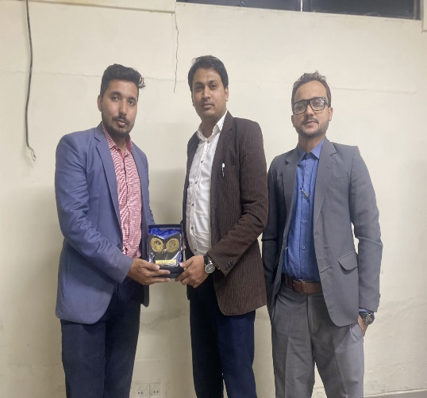
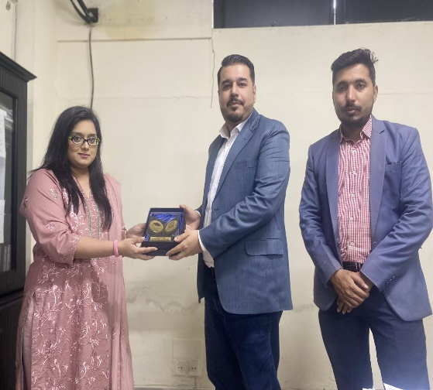
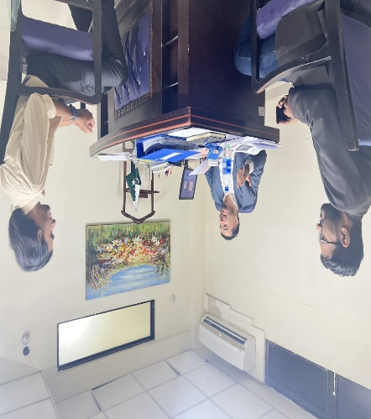

BBA Semester 8 Section C Students participated in this session.

"Career Counselling" Organized by Bahria University Karachi Campus on Thursday, 12th Jan 2023 In Al-Beruni Hall from 2:00 PM to 4:00 PM hours in collaboration with the Student Support Centre and Learning Development Centre.

The session was delivered by Alumni, 𝐖𝐚𝐪𝐚𝐬 𝐊𝐡𝐚𝐭𝐭𝐚𝐤 (𝐁𝐚𝐭𝐜𝐡 𝐨𝐟 𝟐𝟎𝟙𝟙 𝐁𝐁𝐀)

All Department student participated in this session and getting 3 CSP Hours
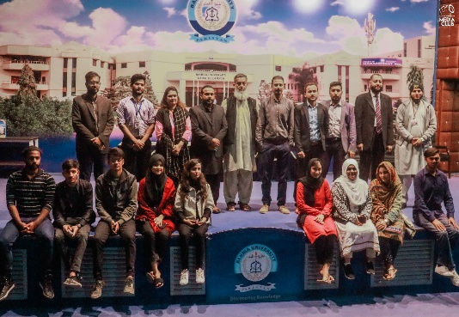
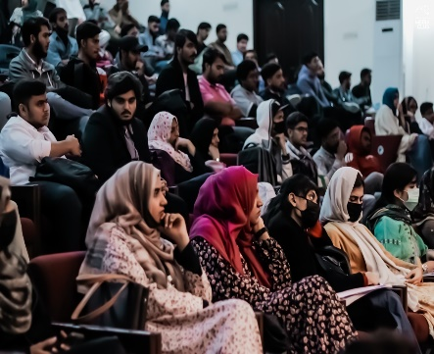
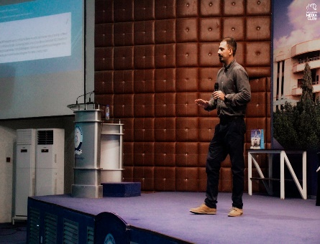

Bahria University Karachi Campus, Student Support Center conducted a session on Immigration and Visa Services Australia on 17 January 2023 which was delivered by our valued alumni Mr. Salman Hussain who is currently working as Immigration Lawyer in Australia.
All Department student participated in this session and getting 3 CSP Hours
